1.
Preheat the oven to 220°C/ 200°C (fan)/ gas 7
Soak your skewers in cold water (this prevents them from burning whilst cooking)
Trim the green stalk off the aubergine[s] and slice, lengthways into 8 [16] rounds
Chop the peppers into large chunks (scrape the seeds and pith out with a teaspoon)
Peel and cut the red onions into large wedges
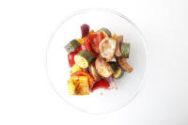
2.
Add the chopped veg to a large bowl, drizzle with 2 tbsp [4 tbsp] vegetable oil and season with a pinch of pepper
Add the curry powder to the bowl and give everything a good mix up – this is your coated veg
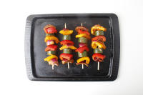
3.
Thread the coated veg onto the soaked skewers, alternating as you go
Add the veg skewers (and any remaining veg) to a baking tray (use tin foil to avoid mess!)
Put the tray in the oven for 10-15 min or until everything has browned and is starting to char - these are your roasted veg skewers
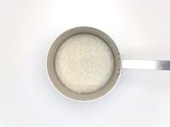
4.
Whilst the veg is cooking, add the basmati rice and 300ml [600ml] cold water to a pot with a lid and bring to the boil over a high heat
Once boiling, reduce the heat to very low, and cook, covered, for 10-12 min or until all the water has absorbed and the rice is cooked
Once cooked, remove from the heat and keep covered until serving
Boil half a kettle

5.
Chop the creamed coconut roughly (if required!)
Dissolve the chopped creamed coconut with the peanut butter in 200ml [400ml] boiled water – this is your peanut stock
Add the peanut stock to a small pot with the agave, soy sauce and chilli flakes (can't handle the heat? Go easy!) then bring to the boil over a medium-high heat

6.
Cook for 2-4 min or until it has reduced by half and thickened – this is your satay sauce
Chop the coriander finely, including the stalks
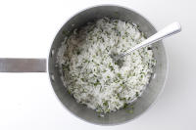
7.
Once the rice is cooked, fluff with a fork and stir the chopped coriander through with a pinch of salt – this is your coriander rice
Serve the roasted veg skewers over the coriander rice
Drizzle the satay sauce over the skewers and serve any remaining satay sauce on the side for dipping
Enjoy!

